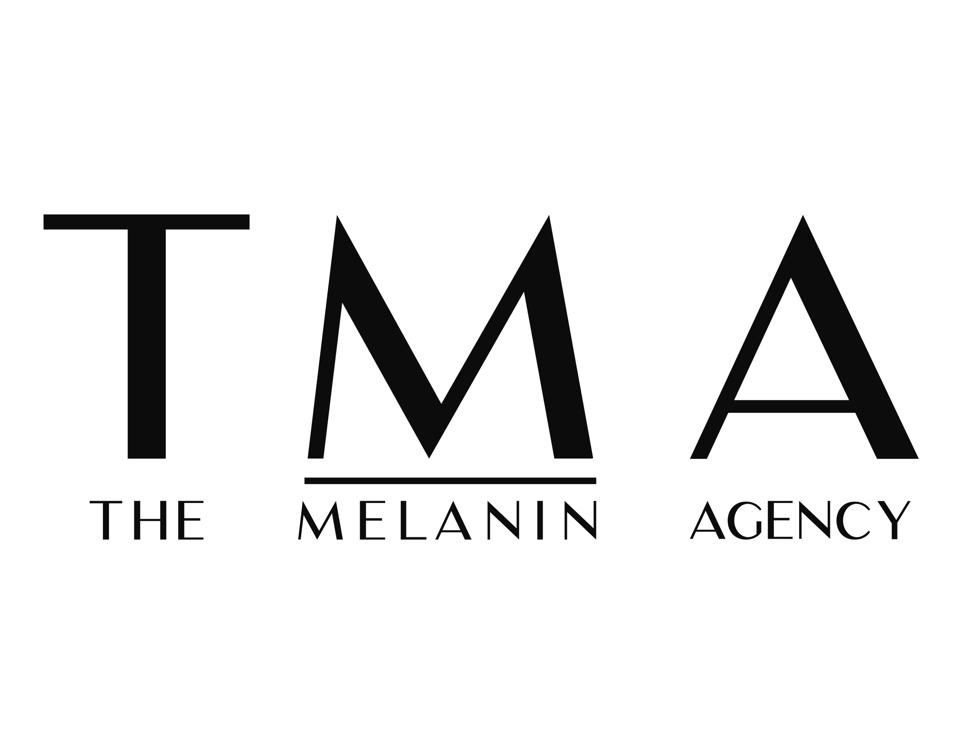

Dan Delgado
Makeup Artist
Dan is a talented, motivated, and ambitious professional makeup artist and groomer based in London. With a keen eye for detail and a passion for enhancing natural beauty, Dan has made a name for himself in the fashion, editorial, and red carpet. His versatile skill set allows him to create everything from soft, effortless glam to bold, full-glam looks, always tailored to meet each client’s unique vision. Known for his calm, professional demeanour and creative precision, Dan has worked with an impressive roster of clients, including Benedict Cumberbatch, Janset, Varada Sethu, and Francesca Rivers. Whether preparing talent for a premiere, editorial shoot, or high-profile event, Dan consistently delivers exceptional results with a polished, camera-ready finish.

Personal Clients

Francesca Amewudah-Rivers, Luke Fetherston, Varada Sethu, Lindsey Vonn, Sophie Hunter, Benedict Cumberbatch, Gugu Mbatha-Raw, 6lack, Olivia Dean, Alexander Lincoln, Miguel Angel Silvestre, Miquita Oliver, Pearl Mackie.

TV

MTV European Music Awards Senior Makeup Artist
November 2024 & 2022

Apple TV Christmas Special Senior Makeup Artist
June 2023

BBC Eurovision Song Contest Senior Makeup Artist
May 2023

Netflix Show Dance 100 Senior Makeup Arist
May 2022

Work Experience

Freelance Makeup Artist January 2013-Present

- Provided makeup for shoots with brands including Burberry, Rejina Pyo, Galvan, Erdem, Matches.com, Ted Baker, Hush, and Karen Millen.
- Created makeup looks for lookbooks and campaigns for brands such as Rejona Pyo, Galvan and Erdem.
- Contributed to editorials for publications such as FT How to Spend it, Allure, British GQ, Vogue Portugal, Chaos SixtyNine, Parq Portugal, Kensington and Chelsea Magazine, Haul Rumenia, Fucking Young, GQ Middle East, ISSUE, KALTBLUT, Also Journal, CACTUS, MMSCENE, 1883, Go Beauty, Renaissance, Candid, Wonderland, Rollercoaster, Man About Town, Rolling Stones UK, and Attitude.

Freelance Lecturer January 2016-2022
London School of Beauty & Makeup
- Delivered high-quality teaching across various makeup courses.
- Guided students through portfolio development, assessments, and projects.
- Provided regular feedback and ensured course requirements were met.
- Assisted in delivering student assessments and progress tracking.
- Adhered to departmental standards and data protection policies.

References
Available upon request.

